COMPETITIVENESS AND INNOVATION FRAMEWORK PROGRAMME
ICT PSP Fifth Call for proposals 2011 - Pilot Type A
Towards a single European electronic identification and authentication area
ICT PSP call identifier: CIP-ICT-PSP-2011-5
ICT PSP Theme/objective identifier: 4.2
Project acronym: STORK 2.0
Project full title: Secure idenTity acrOss boRders linKed 2.0
Grant agreement no.: 297263
VIDP 2.0 Installation Manual
Deliverable Id :
Deliverable Name :
Status :
Dissemination Level : | <PU,CO,RE,PP>
Due date of deliverable :
Actual submission date :
Work Package : | WP 4
Organization name of lead contractor for this deliverable :
Author(s): | Bojan Suzic
Partner(s) contributing : | AT-TUG

Abstract: This document describes the installation, configuration and administration of a VIDP.

History
Version | Date | Modification reason | Modified by
0.1 | 30.3.2014 | Initial documentation | Bojan Suzic
0.2 | 10.6.2014 | Extending sections | Bojan Suzic

Table of contents

History 2
Table of contents 3
List of Figures 5
List of Tables 6
List of abbreviations 7
Executive summary 8
1 Introduction 9
2 Configuration of V-IDP Virtual Machine 10
2.1 Apache httpd instance 10
2.2 Apache Tomcat instance 11
2.3 Setting up and running Apache Tomcat instance 12
2.4 MOA-ID configuration files 14
2.5 MySQL Configuration files 14
3 Configuration of V-IDP and its components 16
3.1 MySQL configuration 16
3.2 Preparing basic MOA configuration 16
3.3 Preparing MOA configuration interface 19
3.4 Configuring specific Stork support for MOA 21
3.5 General MOA configuration 22
3.5.1 Public URL Prefix 23
3.5.2 SecurityLayer Request Templates 24
3.5.3 Certificate check 24
3.5.4 Session timeouts 25
3.5.5 MOA-SPSS Configuration 25
3.5.6 External Services 26
3.5.7 Single Sign-On 27
3.5.8 Secure Identity Accross Borders Linked 27
3.5.9 Logging 28
3.5.10 Security Layer Transformations 28
3.6 Setting up particular service provider 28
3.6.1 Basic Settings 29
3.6.2 CCE Configuration 29
3.6.3 Mandates 30
3.6.4 Secure Identity Across Borders Linked 31
3.6.5 Additional general settings 32
3.6.6 CCE-Selection and Send-Assertion Templates 32
3.7 Other functionality of MOA-ID web configuration interface 35
3.8 Configuring BKUOnline 35
3.8.1 Adjusting configuration file 35
3.8.2 Configuring SSL certificates 36
3.8.3 Logging configuration 36
4 Deployment of V-IDP package 37
4.1 System requirements 37
4.2 Package contents 37
4.3 Create MySQL databases 38
4.4 Copy and set up MOA-ID configuration files 38
4.5 Create and populate MOA-ID Keystore 39
4.6 Configure environment variables 39
4.7 Copy endorsed files to Tomcat’s endorsed directory 39
4.8 Install JCE Policy files 39
4.9 Copy ext files to ext directory of Java distribution 39
4.10 Deploy included WAR files 40
4.11 Configure BKUOnline and disable support for Austrian Test Cards 40
4.12 Install production SSL certificate 40
4.13 Setup general settings of MOA-ID 40
4.14 Initialize and setup MOA-ID web configuration interface 40
4.15 Setup MOA-ID and service provider application via web interface 40
4.16 Security 41
4.17 Testing credentials for mobile citizen card environment 41
5 References 42

List of Figures
Figure 1: Mod_jk configuration (excerpt) 11
Figure 2: Definition of variables (excerpt) 13
Figure 3: Passing variables to Tomcat (excerpt) 13
Figure 4: Resetting MySQL password 15
Figure 5: SamlEngine general configuration 21
Figure 6: Saml Signature Engine configuration 22
Figure 7: Example general configuration interface screen 22
Figure 8: Example configuration of C-PEPS URLs and attributes 28
Figure 9: Example AuthBlockText configuration 32
Figure 10: Example transformation result of customized AuthTextBlock 32
Figure 11: Example configuration of service provider application 34
Figure 12: Creating new users 35
Figure 13: BKUOnline whitelist hosts 35
Figure 14: Setting up MySQL 38
Figure 15: Application settings 41

List of Tables
Table 1: Relevant Apache httpd server and mod_jk paths 10
Table 2: Relevant Apache Tomcat paths 11
Table 3: Paths and URLs of deployed applications 12
Table 4: Relevant variables 13
Table 5: Configuration of MOA components 14
Table 6: MySQL relevant paths 14
Table 7: Preconfigured MySQL databases 16
Table 8: MOA-ID basic configuration 17
Table 9: MOA-ID database configuration 18
Table 10: Web interface configuration for MOA-ID 20
Table 11: MOA-ID web configuration interface database configuration 21
Table 12: MOA-ID general configuration 23
Table 13: Citizen Card Environments used by MOA-ID globally 23
Table 14: Security Layer templates used by Citizen Card Environment 24
Table 15: Configuration of trusted certificates 25
Table 16: Session timeouts configuration 25
Table 17: MOA-SPSS configuration parameters 26
Table 18: Configuration of external services 26
Table 19: Configuration of Single Sign-On parameters 27
Table 20: Basic settings for service provider application 29
Table 21: Citizen Card Environment settings for service provider application 30
Table 22: Mandates supported by service provider application 31
Table 23: Attribute providers settings 31
Table 24: CCE-Selection and Send-Assertion Templates 33
Table 25: Contents of deployment archive 37
Table 26: Contents of configuration directory in deployment archive 37

List of abbreviations
<Abbreviation> <Explanation>
AQAA Attribute Quality Authentication Assurance
AT Austria
AP Attribute Provider
BE Belgium
CH Switzerland
CZ Czech Republic
EE Estonia
eID Electronic Identity
ES Spain
EU European Union
FR France
GR Greece
IS Iceland
IT Italy
LT Lithuania
LU Luxembourg
MS STORK2.0 Member State
MW MiddleWare
NL The Netherlands
PEPS Pan European Proxy Server
PT Portugal
QAA Quality Authentication Assurance
SAML Security Assertion Markup Language
SE Sweden
SI Slovenia
SK Slovakia
SP Service Provider
STORK 2.0 Secure idenTity acrOss boRders linKed 2.0
TR Turkey
UK United Kingdom
V-IDP Virtual Identity Provider
WP Work Package

Executive summary
This document is targeting system administrators and operators, as well as the users of V-IDP system who will deploy or harden V-IDP systems at their local premises.
It provides quick reference on installation and configuration of V-IDP system. It covers the reference installation of preconfigured V-IDP system provided by Graz University of Technology and A-SIT Austria. Furthermore, the document explains the structure of V-IDP deployment archive, provides the steps necessary to execute during its separate deployment and configuration.
When you finish reading this document you should be able to install and configure V-IDP system, to gain better understating of its function and provide primary support in the case of troubleshooting.

Introduction

This document consists of two main parts.
The first part explains the structure and configuration of provided V-IDP reference system installation in the form of Debian Wheezy virtual machine.
The second part of the document provides the information on manual deployment of V-IDP system based on accompanying V-IDP deployment archive. It explains main steps involved in that process and provides hints and links to the settings already done and explained a the reference system.
For further questions, suggestions and comments please contact Austrian V-IDP team. Detailed contact informations are available at STORK 2 Wiki pages.

Configuration of V-IDP Virtual Machine
Austria provides all PEPS countries with reference virtual machine that can be used to easily deploy V-IDP system.
The virtual machine is based on Debian 7.4 distribution and contains optimal set of packages necessary to run the V-IDP services, including the following set of components:

- Linux kernel 3.2.0-4-amd64
- Sun Java SDK 1.7.0_51-b13
- Apache httpd 2.2.22-13
- Apache Tomcat 7.0.28-4
- Apache 2 mod_jk 1.2.37
- MySQL Server 5.5.35

The client HTTP(S) request coming to the V-IDP system are served by Apache httpd front-end server, which is installed and configured in its standard Debian flavor. It contains additional mod_jk module, which interfaces with backend Apache Tomcat server. The Apache Tomcat server instance included in this reference system contains all relevant modules belonging to the V-IDP. Installed MySQL Server instance is used to store configuration, session and statistics related data. The installation is based on the one shipped with default Debian distribution, configured according to standard Debian practices.
Table 2 provides the list of configuration locations relevant for configured Apache Tomcat instance.

The credentials used to login to the virtual machine are:
User: stork
Password: st12knn

Apache httpd instance
The reference system runs Apache 2 instance with mod_jk module. It acts as a frontend on standard HTTP(s) ports and using mod_jk connects to local Tomcat service running MOA-ID application.

Path | Description
/etc/apache2/ | Base configuration directory
/etc/apache2/mods-enabled | Enabled modules, links to configuration of modules
/etc/apache2/ssl | Location for SSL certificates
/var/log/apache2 | Apache log files
Table 1: Relevant Apache httpd server and mod_jk paths

The Apache2 instance can be started and stopped by issuing the following commands:

service apache2 stop

service apache2 start

The following figure provides the excerpt of configuration of mod_jk module.

JkWorkersFile /etc/libapache2-mod-jk/workers.properties
JkLogFile /var/log/apache2/mod_jk.log
JkLogLevel info
JkShmFile /var/log/apache2/jk-runtime-status
JkWatchdogInterval 60
<Location /jk-status>
JkMount jk-status
Order deny,allow
Deny from all
Allow from 127.0.0.1
</Location>
<Location /jk-manager>
JkMount jk-manager
Order deny,allow
Deny from all
Allow from 127.0.0.1
</Location>
Figure 1: Mod_jk configuration (excerpt)

Apache Tomcat instance
The reference system runs Apache Tomcat 7 instance containing the MOA applications. Table 2 provides the list and description of the most relevant paths of Tomcat installation.

Path | Description
/usr/share/tomcat7 | Contains Tomcat binaries an libraries
/var/lib/tomcat7 | Contains shared and common files, deployment and directory for endorsed files
/var/lib/tomcat7/webapps | Contains Austrian authentication middleware
/etc/tomat7 | Configuration directory
/var/log/tomcat7 | Log files
Table 2: Relevant Apache Tomcat paths

The Tomcat server contains web modules ConfigurationInterface, moa-id-auth and bkuonline, that basically build up the V-IDP system. They are by default deployed under webapps directory.

The following list briefly summarizes their role:
- ConfigurationInterface
Provides the web based configuration interface for MOA. This interface is used to configure general MOA options, as well as to add and configure individual online applications (service providers).
- moa-id-auth
Set of software tools which provide implementation and integration support for the functions and procedures mandate by the Austrian eGov strategy. Contains integrated support for Stork 2 functionalities.
- bkuonline
Modular Austrian citizen-card environment. Provides online module and interface interacting the user’s citizen card.

The following table provides overview on deployed applications:

Path | URL
bkuonline | https://testvidp.buergerkarte.at/bkuonline
moa-id-auth | https://testvidp.buergerkarte.at/moa-id-auth
moa-id-configuration | https://testvidp.buergerkarte.at/moa-id-configuration
Table 3: Paths and URLs of deployed applications

Setting up and running Apache Tomcat instance
Before the Tomcat instance is initialized, the necessary environment variables are passed to the server and applications.
The following table contains the list of included variables. In reference installation they are found in the file /etc/tomcat7/set-variables.sh.

Variable | Description
LOGS_DIR | Destination of log data
CATALINA_OUT | Log file containing Tomcat’s standard output
LOGS_BASE | Base directory for other logs
LOGGING_OPT | Points to file containing logging configuration
FILE_ENCODING | Sets file encoding
MOA_ID_CONFIG | Location of base MOA-ID configuration file
MOA_ID_CONFIG_TOOL | Location of base MOA-ID web interface configuration file
MOA_ID_STORK | Location of STORK related files such as SAMLEngine configurations
MOA_SPSS_CONFIG | Points to MOA-SPSS configuration file
MOA_SPSS_TSL_HASHCACHE | Caching directory used by MOA-SPSS
JAVA_ENDORSED_DIRS | Path to endorsed directory
Table 4: Relevant variables

The following two figures contain the excerpts from /etc/tomcat7/set-variables.sh. The parameters in this file are used to set and pass MOA-ID and other configuration options to MOA-ID running under Tomcat.
JAVA_HOME=/usr/lib/jvm/java

LOGS_DIR=/var/log/tomcat7/moaid-2.0
CATALINA_OUT=$LOGS_DIR/catalina.out
LOGS_BASE=-Dlogs.base=$LOGS_DIR

LOGGING_OPT=-Dlog4j.configuration=file:$CATALINA_BASE/conf/log4j.properties
FILE_ENCODING=-Dfile.encoding=UTF-8

RAND_FILE=-Djava.security.egd=file:/dev/urandom

MOA_ID_CONFIG=-Dmoa.id.configuration=$CATALINA_BASE/conf/moa-id/moa-id.properties
MOA_ID_CONFIG_TOOL=-Dmoa.id.webconfig=$CATALINA_BASE/conf/moa-id-configuration/moa-id-configtool.properties
MOA_ID_STORK=-Deu.stork.samlengine.config.location=$CATALINA_BASE/conf/moa-id/stork/

MOA_SPSS_CONFIG=-Dmoa.spss.server.configuration=$CATALINA_BASE/conf/moa-spss/MOASPSSConfiguration.xml
MOA_SPSS_TSL_HASHCACHE=-Diaik.xml.crypto.tsl.BinaryHashCache.DIR=$CATALINA_BASE/conf/moa-spss/tslworking/hashcache/

JAVA_ENDORSED_DIRS=$CATALINA_BASE/endorsed
Figure 2: Definition of variables (excerpt)
JAVA_OPTS="$LOGS_BASE $FILE_ENCODING $LOGGING_OPT $MOA_ID_CONFIG $MOA_SPSS_CONFIG $MOA_ID_CONFIG_TOOL -Dsun.security.ssl.allowUnsafeRenegotiation=true $RAND_FILE
-XX:PermSize=64m -XX:MaxPermSize=786m $MOA_ID_STORK"

JVM_OPTS="$FILE_ENCODING;$LOGGING_OPT;$MOA_ID_CONFIG;$MOA_SPSS_CONFIG;$MOA_ID_CONFIG_TOOL;-Dsun.security.ssl.allowUnsafeRenegotiation=true;$RAND_FILE;
-XX:PermSize=64m;-XX:MaxPermSize=786m;$MOA_ID_STORK"

CATALINA_OPTS="$LOGGING_OPT $FILE_ENCODING $MOA_ID_CONFIG $MOA_SPSS_CONFIG $MOA_SPSS_TSL_HASHCACHE $PARAM_TRUST_STORE $PARAM_TRUST_STORE_PASS $PARAM_TRUST_STORE_TYPE $PARAM_SSL_DEBUG $MOA_ID_CONFIG_TOOL -Dsun.security.ssl.allowUnsafeRenegotiation=true $RAND_FILE -XX:MaxPermSize=786m $MOA_ID_STORK"
Figure 3: Passing variables to Tomcat (excerpt)

The Tomcat 7 instance can be started and stopped by issuing the following commands:

service tomcat7 stop

service tomcat7 start

MOA-ID configuration files
Table 5 presents the list of MOA-ID and related paths, as well as brief explanations on their contents. The referenced directories are available under Tomcat configuration directory – in the case of reference system it is /etc/tomcat7.

Path | Description
moa-id | The base directory for MOA-ID configuration
moa-id/keys | Contains keystore used by SAMLEngine
moa-id/stork | Contains STORK related SAMLEngine configuration files
moa-id-configuration | Configuration of MOA-ID web configuration interface, as well as templates and transformations
moa-spss | MOA-SPSS directory containing MOA-SPSS configuration, trust and cert store as well as transformation profiles
Table 5: Configuration of MOA components

MySQL Configuration files
Table 6 contains the list of the relevant MySQL server paths. The files contained there are already preconfigured and should not be normally changed.

Path | Description
/etc/mysql | The base directory for configuration of MySQL server
/etc/mysql/debian.cnf | Automatically generated configuration by Debian – should not be changed directly
/etc/mysql/my.cnf | MySQL server main configuration file
/var/log/mysql | MySQL server log location
Table 6: MySQL relevant paths

Both the username and password used to connect to MySQL server are vidp. The users are advised to change the password, as well to reset the root MySQL password. The later can be done by executing the following set of commands:

sudo /etc/init.d/mysql stop
sudo mysqld_safe --skip-grant-tables &

mysql -u root
use mysql;
update user set password=PASSWORD("mynewrootpassword") where User='root';
update user set password=PASSWORD("mynewvidppassword") where User='vidp';
flush privileges;
quit

sudo /etc/init.d/mysql stop
sudo /etc/init.d/mysql start

Figure 4: Resetting MySQL password

The code shown in Figure 4 should be entered in Debian command line. The first part of the code is used to start MySQL server in safe mode. The middle part is then used to log in MySQL instance and set the passwords for root and vidp users. At the end, the instance is restarted in normal mode.

Configuration of V-IDP and its components

This section presents the configuration of V-IDP software components.
All references to specific files or directories in this section are based on reference installation provided in the form of V-IDP virtual machine, as introduced in Section 2: Configuration of V-IDP Virtual Machine. Therefore, these paths should be adjusted correctly in the case of specific configuration based on manual deployment and installation of modules.

MySQL configuration
The V-IDP requires storage backend in order to store the necessary configuration, session and statistics data. For such reason it comes with MySQL server preinstalled and three preconfigured databases, as shown in Table 7: Preconfigured MySQL databases.

Database | Description
moa-id-config | Various configuration settings
moa-id-session | Temporary session data
moa-id-statistics | Statistics on MOA-ID usage
Table 7: Preconfigured MySQL databases

Both the username and password used to connect to MySQL server are vidp.
Users are advised to change MySQL credentials and adjust server and access settings to conform to local deployment environment and security requirements.

Preparing basic MOA configuration
Before MOA instance is started, it is necessary to review and configure its configuration parameters available under /etc/tomat7/moa-id/moa-id.properties. This file provides basic configuration which is necessary to start MOA service.
This file contains some parameters which are used in specific scenarios relevant for providers using other types of interfaces or authentication, internally in Austria. In the context of Stork 2 deployment, most of these parameters are not used and there for not relevant. The following table lists the most relevant parameters for deployment case in the terms of Stork 2 scenario:

Parameter |  | configuration.moasession.key
 | Example | MyKey123
 | Description | Passphrase used to encrypt the session data in database. Optional.
Parameter |  | Configuration.monitoring.active
 | Example | true
 | Description | Defines the status of monitoring servlet
Parameter |  | Configuration.monitoring.message.success
 | Example | True
 | Description | Success message sent in case of passing the tests
Parameter |  | Configuration.monitoring.test.identitylink.url
 | Example | /test/idl/test_identitylink.xml
 | Description | URL of IdentityLink used for testing
Parameter |  | configuration.advancedlogging.active
 | Example | true
 | Description | Defines the status of additional logging facilities (in database)
Table 8: MOA-ID basic configuration

The next table contains description of database configuration parameters on MOA-ID related to session data store, configuration and statistics data store.

Parameter |  | moasession.hibernate.dialect
 | Example | org.hibernate.dialect.MySQLDialect
 | Description | Dialect used to communicate with MOA-session data store
Parameter |  | moasession.hibernate.connection.url
 | Example | jdbc:mysql://localhost/moa-id-session?charSet=utf-8&autoReconnect=true
 | Description | URL to MOA-session database schema
Parameter |  | moasession.hibernate.connection.driver_class
 | Example | com.mysql.jdbc.Driver
 | Description | Driver used to access session database
Parameter |  | moasession.hibernate.connection.username
 | Example | moasession
 | Description | The user name used to access the session database
Parameter |  | moasession.hibernate.connection.password
 | Example | moapassword
 | Description | The password used to access the session database
Parameter |  | configuration.hibernate.dialect
 | Example | org.hibernate.dialect.MySQLDialect
 | Description | Dialect used to communicate with MOA-configuration data store
Parameter |  | configuration.hibernate.connection.url
 | Example | jdbc:mysql://localhost/moa-id-config?charSet=utf-8&autoReconnect=true
 | Description | URL to MOA-config database schema
Parameter |  | configuration.hibernate.connection.driver_class
 | Example | com.mysql.jdbc.Driver
 | Description | Driver used to access config database
Parameter |  | configuration.hibernate.connection.username
 | Example | moaconfiguser
 | Description | The user name used to access the database
Parameter |  | moasession.hibernate.connection.password
 | Example | moaconfigpassword
 | Description | The password used to access the database
Parameter |  | advancedlogging.hibernate.dialect
 | Example | org.hibernate.dialect.MySQLDialect
 | Description | Dialect used to communicate with data store for MOA advanced logging
Parameter |  | advancedlogging.hibernate.connection.url
 | Example | jdbc:mysql://localhost/moa-id-statistics?charSet=utf-8&autoReconnect=true
 | Description | URL to advanced logging database schema
Parameter |  | advancedlogging.hibernate.connection.driver_class
 | Example | com.mysql.jdbc.Driver
 | Description | Driver used to access advanced logging database
Parameter |  | advancedlogging.hibernate.connection.username
 | Example | moaloguser
 | Description | The user name used to access the advanced statistics database
Parameter |  | moasession.hibernate.connection.password
 | Example | moalogpassword
 | Description | The password used to access the advanced statistics database
Table 9: MOA-ID database configuration

Preparing MOA configuration interface
The module for MOA web configuration interface is started separately. Its basic configuration can be adjusted under /etc/tomcat7/moa-id-configiguration/moa-id-configtool.properties. All other application relevant parameters are further defined in this configuration interface. The following table provides description of most relevant parameters in this file.

Parameter |  | general.login.deaktivate
 | Example | false
 | Description | With this option login using web interface can be deactivated.
Parameter |  | general.publicURLContext
 | Example | https://testvidp.buergerkarte.at/ConfigurationInterface
 | Description | This is the URL of web configuration interface
Parameter |  | general.defaultlanguage
 | Example | de
 | Description | Defines default language for web configuration interface
Parameter |  | general.mail.host
 | Example | mail.testvidp.buergerkarte.at
 | Description | The mail server used to send the emails
Parameter |  | general.mail.from.name
 | Example | TestVIDP System
 | Description | The name of the sender of emails
Parameter |  | general.mail.from.address
 | Example | admin@testvidp.buergerkarte.at
 | Description | The from address used when sending emails from the host
Parameter |  | general.mail.useraccountrequest.verification.subject
 | Example | MOA-ID User verification
 | Description | Subject of verification email sent when opening account
Parameter |  | general.mail.useraccountrequest.verification.template
 | Example | mail/verification_template.html
 | Description | Location of the verification’s email template
Parameter |  | general.mail.useraccountrequest.isactive.subject
 | Example | MOA-ID User Activation
 | Description | Subject of activation mail sent after the account is activated
Parameter |  | general.mail.useraccountrequest.isactive.template
 | Example | mail/activation_template.html
 | Description | Location of the activation’s email template
Parameter |  | general.mail.useraccountrequest.rejected.template
 | Example | mail/rejected_template.html
 | Description | Location of the template used to inform the user about rejection or removal of its requested account.
Parameter |  | general.mail.createOArequest.isactive.subject
 | Example | MOA-ID Service Provider Activation
 | Description | Subject of activation mail for service provider (online application)
Parameter |  | general.mail.createOArequest.isactive.template
 | Example | mail/oa_activation_template.html
 | Description | Location to the template used for service provider activation email
Parameter |  | general.mail.admin.adress
 | Example | admin@testvidp.buergerkarte.at
 | Description | Email address of system admin
Parameter |  | general.mail.admin.subject
 | Example | MOA-ID Status information
 | Description | Subject of status information message
Parameter |  | general.mail.admin.adresses.template
 | Example | mail/admin_template.html
 | Description | Location of status information/change template sent to the admin
Table 10: Web interface configuration for MOA-ID

In the following table described are database specific configuration parameters:
Parameter |  | hibernate.dialect
 | Example | org.hibernate.dialect.MySQLDialect
 | Description | The SQL dialect used to store configuration
Parameter |  | hibernate.connection.url
 | Example | jdbc:mysql://localhost/moa-id-config?charSet=utf-8&autoReconnect=true
 | Description | URL used to access the database (configuration store)
Parameter |  | hibernate.connection.driver_class
 | Example | com.mysql.jdbc.Driver
 | Description | Driver class used to access the database
Parameter |  | hibernate.connection.username
 | Example | Vidp
 | Description | The username used to access the database
Parameter |  | hibernate.connection.password
 | Example | Vidppass
 | Description | The password used to access the database
Table 11: MOA-ID web configuration interface database configuration

Configuring specific Stork support for MOA
Common SAMLEngine developed in the course of STORK project is used for the signing and verification of STORK SAML messages. Its specific configuration files can be found under /etc/tomcat7/moa-id/stork.
The main file for defining sub-configurations located in this directory is SamlEngine.xml. This file defines and references instance configurations for each profile used in the application.

The following is snippet excerpt from SamlEngine.xml:

<instance name="VIDP">
<!-- Configurations parameters StorkSamlEngine -->
<configuration name="SamlEngineConf">
<parameter name="fileConfiguration" value="StorkSamlEngine_VIDP.xml" />
</configuration>
<!-- Settings module signature-->
<configuration name="SignatureConf">
<!-- Specific signature module -->
<parameter name="class" value="eu.stork.peps.auth.engine.core.impl.SignSW" />
<!-- Settings specific module -->
<parameter name="fileConfiguration" value="SignModule_VIDP.xml" />
</configuration>
</instance>
Figure 5: SamlEngine general configuration

In this example, the instance references two additional files, StorkSamlEngine_VIDP.xml and SignModule_VIDP.xml. Each configuration in the system requires such instance designation and further definition of particular SamlEngine and SignatureEngine subsections. In SamlEngine configuration contained are the attribute definitions and other settings – there is generally no need to adjust those files. On the other hand, SignatureEngine contains settings necessary to access keystore used to sign and verify SAML messages.

The following is snippet excerpt from that file:

<properties>
<comment>SWModule sign with JKS.</comment>
<entry key="keystorePath">/etc/tomcat7/moa-id/keys/storkDemoKeys.jks</entry>
<entry key="keyStorePassword">change-me</entry>
<entry key="keyPassword">change-me</entry>
<entry key="issuer">C=AT, L=Graz, OU=Test Institute, CN=EuroPKI CA</entry>
<entry key="serialNumber">2FCAA2CDB1522</entry>
<entry key="keystoreType">JKS</entry>
</properties>

Figure 6: Saml Signature Engine configuration
Generally nearly all the lines from the previous configuration snippet should be adjusted in order to reflect local configuration.
Referenced keystore should contain trust certificates from other trusted parties, such as PEPSes, and private key used to sign message delivered to the peers.

General MOA configuration
General configuration in MOA is accessed through web configuration interface of MOA-ID. By default, this interface is located at https://vidp-domain.tld/moa-id-configuration.

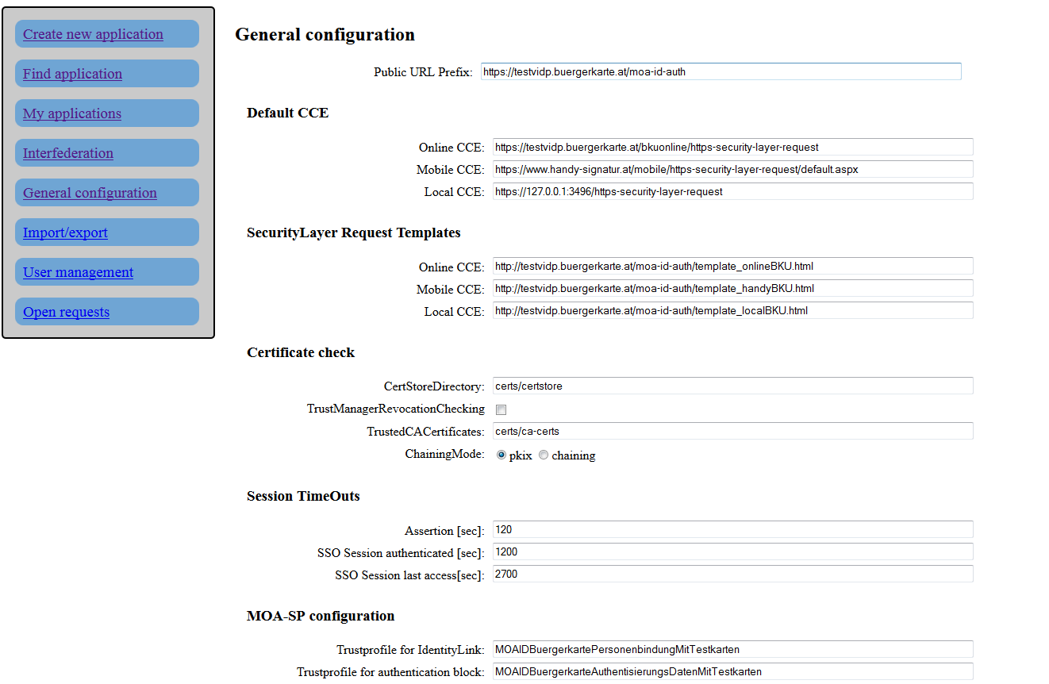
Figure 7: Example general configuration interface screen

Figure 7 shows the web page of configuration interface, located in general configuration section of MOA-ID.
The default login data for MOA-ID configuration interface are:
Username: stork
Password: st12knn
In order to access MOA-ID configuration it might be necessary to temporarily disable login functionality and create a new user. The more details are provided in Section 4.15.
The following subsections contain most important options for Stork based system setup.

Public URL Prefix
Parameter |  | Public URL Prefix
 | Example | https://testvidp.buergerkarte.at/moa-id-auth
 | Description | URL-Prefix of MOA-ID instance. This setting is used for automatic generation of forms and information and must be defined.
Table 12: MOA-ID general configuration

In this section defined are the parameters for standard Citizen Card Environment. They are used by MOA-ID in the authentication process in the case there is no specific CCE defined for particular service provider.

Parameter |  | Online CCE
 | Example | https://testvidp.buergerkarte.at/bkuonline/https-security-layer-request
 | Description | URL to the Online-CCE instance
Parameter |  | Mobile CCE
 | Example | https://www.handy-signatur.at/mobile/https-security-layer-request/default.aspx
 | Description | URL to the Mobile-CCE instance
Parameter |  | Local CCE
 | Example | https://127.0.0.1:3496/https-security-layer-request
 | Description | URL pointing to the locally installed and executed CCE instance
Table 13: Citizen Card Environments used by MOA-ID globally

SecurityLayer Request Templates
Security Layer Templates are used in the communication with previously configured Citizen Card Environment. The communication is based on HTTP Form, which is sent to the Citizen Card Environment through HTTP POST Request.
Necessary templates are included as a part of V-IDP distribution. They can be further customized and configured, however that is out of scope of this setup.

Parameter |  | Online CCE
 | Example | http://testvidp.buergerkarte.at/moa-id-auth/template_onlineBKU.html
 | Description | SL Template for communication with Online-CCE
Parameter |  | Mobile CCE
 | Example | http://testvidp.buergerkarte.at/moa-id-auth/template_handyBKU.html
 | Description | SL Template for communication with Mobile-CCE
Parameter |  | Local CCE
 | Example | http://testvidp.buergerkarte.at/moa-id-auth/template_localBKU.html
 | Description | SL Template for communication with local CCE instance
Table 14: Security Layer templates used by Citizen Card Environment

Certificate check
In this section considered are general settings for certificate check and the configuration of trusted certificates. Referenced directories are relative to MOA-ID configuration directory – in the case of this reference installation it is /etc/tomcat7/moa-id.

Parameter |  | CertStoreDirectory
 | Example | certs/certstore
 | Description | Path name to the directory containing trust store used in the course of TLS server based certificate check.
Parameter |  | TrustManagerRevocationChecking
 | Example | false
 | Description | For TLS server based authentication there can be used only server certificates containing CRLDP extension. If there is no CRLDP extension contained, MOA-ID would not be able to perform CRL based check. If RevocationChecking is disabled, this setting should be set to false.
Parameter |  | TrustedCACertificates
 | Example | certs/ca-certs
 | Description | Path to the directory containing trusted CA certificates. In the course of TLS server based certificate check these CA would be considered as trusted.
Parameter |  | Chaining Mode
 | Example | pkix
 | Description | This option defines if the certificate check method would be based on chaining or on RFC 3280 pkix.
Table 15: Configuration of trusted certificates

Session timeouts
This subsection defines general timeouts used in the system, expressed in seconds.

Parameter |  | Assertion
 | Example | 120
 | Description | Defines the time window for authentication data, session data or assertions contained in the system to be considered as valid. After this time is passed the data will be removed or the authentication process canceled.This setting influences the maximal time allowed to collect additional STORK attributes.
Parameter |  | SSO Session authenticated
 | Example | 1200
 | Description | Defines time window for validity of Single Sign-On session, starting from the time point of authentication. After the expiration of this period, the user will have to authenticate again.
Parameter |  | SSO Session last access
 | Example | 2700
 | Description | Defines time window for validity of Single Sign-On session, starting from the time point of the last access. After the expiration of this period, the user will have to authenticate again.
Table 16: Session timeouts configuration

MOA-SPSS Configuration
This sections defines relevant parameters for configuring the options of MOA-SP module, which is used for checking of signature of identity link and authentication block. This module is shipped a part of MOA-ID and in Stork based scenario should generally not be adjusted.

Parameter |  | Trustprofile for Identity Link
 | Example | MOAIDBuergerkartePersonenbindungMitTestkarten
 | Description | This element specifies TrustProfileID used during verification of signature of the identity link, a part of signature request. The same TrustProfileID must be configured in the corresponding MOA-SP module.
Parameter |  | Trustprofile for authentication block
 | Example | MOAIDBuergerkarteAuthentisierungsDatenMitTestkarten
 | Description | This element specifies TrustProfileID used during verification of signature of the authentication block, a part of signature request. The same TrustProfileID must be configured in the corresponding MOA-SP module.
Parameter |  | Transformations for authentication block
 | Example | MOAIDTransformAuthBlockTable_DE_new
 | Description | This option defines ID of transformations profile, used during the verification of the signature of authentication block. The same transformation profile must be configured in the corresponding MOA-SP module.
Parameter |  | URL for MOA-SP service
 | Example | http://testinstance.tld/moaspss
 | Description | URL of the used MOA-SP service. Optional.  If this option is not configured, the MOA-ID will use the integrated version of MOA-SP. The MOA-SP configuration can be found under /etc/tomcat7/moa-spss/MOASPSSConfiguration.xml.
Table 17: MOA-SPSS configuration parameters

External Services
The following parameters are used for communication with external services such as online mandating service and source-PIN registry. These parameters should be configured only in special cases.

Parameter |  | Online-Mandate Service URL
 | Example | https://vollmachten.egiz.gv.at/mis-test/MandateIssueRequest
 | Description | URL of online mandating service
Parameter |  | SZR Gateway Service URL
 | Example | https://szrgw.egiz.gv.at/services_2.0/IdentityLinkCreation
 | Description | URL of source-PIN registry
Table 18: Configuration of external services

Single Sign-On
The options in this section define the parameters necessary for implementation of single sign-on functionality. This functionality is currently not relevant for STORK 2 application.

Parameter |  | SSO Service Name:
 | Example
 | Description
Parameter |  | SSO Service Target
 | Example
 | Description
Parameter |  | SSO Auth Block Text
 | Example
 | Description
Table 19: Configuration of Single Sign-On parameters

Secure Identity Accross Borders Linked
The parameters from this section specify the settings directly relevant for Stork deployment.
In this section it is possible to define standard QAA-Level of requests, which sets minimal requirements for QAA.
Further, for each relevant country the appropriate C-PEPS URL should be entered.
The next available setting is configuration of attributes. In this subsection defined are generally supported STORK attributes, such as eIdentifier, givenName and others. The field mandatory is used to mark the attributes which must be included in the response from PEPS. Figure 8 shows the example configuration of attributes.
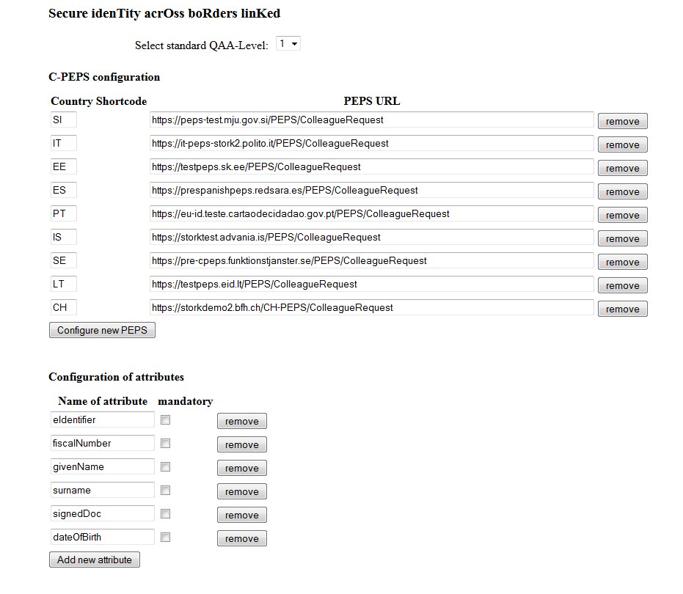
Figure 8: Example configuration of C-PEPS URLs and attributes

Logging
This subsection allows specific settings for logging configuration. These are not relevant for STORK based deployments.

Security Layer Transformations
The SL-Transformations are used by MOA-ID to create the signature of authentication block. The transformation file should be uploaded separately through this interface. The standard configuration is available under:
/etc/tomcat/moa-id/transforms/TransformsInfoAuthBlockTable_DE_new.xml.

Setting up particular service provider
The configuration of service provider is initiated from the main web-interface menu, under the option Interfederation > STORK VIDP. The list of available applications can be invoked through the option Interfederation. Furthermore, the service provider configuration is generally done by the users with administrator rights, but the basic settings for particular applications can be also done by other users registered in the system.

Basic Settings
This section defines the basic and parameters of service provider, such as its name and URL.
Parameter |  | Online-Application is activated
 | Example | true
 | Description | Allows to activate and deactivate service provider application.
Parameter |  | Unique identifier (PublicURLPrefix):
 | Example | https://peps-test.gov.tld/SP/ReturnPage
 | Description | This parameter is used to distinguish service provider applications and find/retrieve the specific one. The identificator should contain at least the URL prefix of externally visible and reachable service provider application
Parameter |  | Name of the Online-Application:
 | Example | Demo SP
 | Description | User defined name of service provider. It is shown during user authentication process.
Parameter |  | Private sector application
 | Example | true
 | Description | This parameter should be set to true for STORK service providers
Parameter |  | Identification number:
 | Example | STORK IT
 | Description | This parameter is mandatory and should be used to to set the SP country.
Table 20: Basic settings for service provider application

CCE Configuration
This section defines the citizen card environment which can be used to authenticate users. Please note that Online CCE should point to BKUOnline instance deployed at local premises. Details about that are provided in Section 3.8. Additionally, if you want to use test credentials for Mobile CCE, further details are provided in Section 4.17.

Parameter |  | Online CCE
 | Example | https://testvidp.buergerkarte.at/bkuonline/https-security-layer-request
 | Description | URL to the application specific Online-CCE instance.  If no instance is configured, the default one from the MOA-ID general configuration is applied.
Parameter |  | Mobile CCE
 | Example | https://www.handy-signatur.at/mobile/https-security-layer-request/default.aspx
 | Description | URL to the application specific Mobile-CCE instance.  If no instance is configured, the default one from the MOA-ID general configuration is applied.
Parameter |  | Local CCE
 | Example | https://127.0.0.1:3496/https-security-layer-request
 | Description | URL pointing to the locally installed and executed CCE instance. If no parameter is set, the default one from the MOA-ID general configuration is used.
Parameter |  | KeyBoxIdentifier
 | Example | SecureSignatureKeypair
 | Description | Configures keypair used to sign the authentication block. Default value is SecureSignatureKeypair.
Parameter |  | SecurityLayerTemplates (Legacy Request)
 | Example | false
 | Description | Using this option it is possible to define additional three SecurityLayer templates. In STORK related deployments this selector should be left unchecked.
Table 21: Citizen Card Environment settings for service provider application

Mandates
This subsection allows definition of mandating schemas used in the authentication process.

Parameter |  | Mandates
 | Example | true
 | Description | This setting defines if the service provider application supports online-mandates. If this box is checked, the option to log in as representative will be shown during authentication process at the CCE selection step.
Parameter |  | Profile
 | Example | Gesundheit,Zustellung,ERsB,GeneralvollmachtBilateral
 | Description | This element contains the comma-separated list of mandating profiles. The full list is available under https://vollmachten.stammzahlenregister.gv.at/mis.
Parameter |  | Allow mandated login only
 | Example | false
 | Description | Allows setting the possibility to accept authentication based on powers only.
Table 22: Mandates supported by service provider application

Secure Identity Across Borders Linked
The parameters from this section specify STORK protocol relevant settings for service provider application.
VIDP interface is active parameter is used when the service provider application needs to support the login of the user from other countries. This way, on the login web page the option Home Country Selection will be enabled.
The option Ask the user for attributes transfer consent is applied to activate the user consent request before the user attributes are transferred to peer entity such as PEPS in cross-border scenario.
The next available setting is configuration of List of configured attribute providers. Each entry of the list should contain attribute provider plugin which should handle the request, the URL of attribute provider as well as attributes supported by that provider separated by commas, for example: mandateContent,attribute2.

The following table contains the description of currently supported attribute providers:
Plugin Name |  | EHvdAttributeProvider
 | Example | http://ehvdtest.buergerkarte.at/RetreveAttribute
 | Description | Used in the health domain.
Parameter |  | SignedDocAttributeRequestProvider
 | Example | http://testvidp.buergerkarte.at/RetreveAttribute
 | Description | Used to support document signing using signDoc attribute.
Parameter |  | MISAttributeRequestProvider
 | Example | http://mistest.buergerkarte.at/moa-id-auth/MISProvider
 | Description | Used to enable support of authentication in powers.
Parameter |  | StorkAttributeRequestProvider
 | Example | http://testvidp.buergerkarte.at/RetreveAttribute
 | Description | General plugin, used for other cases.
Table 23: Attribute providers settings

Please note that for the exact URLs of attribute providers covering particular attributes and use cases can be found on Member State Wiki Page for Austria at the STORK 2 web site.
This page contains other information such as SAML signing certificates of these attribute providers, which should be installed at local instance.

Additional general settings
This optional section enables service providers to provide customized, service provider application specific authentication block and citizen card environment selection form.
The option Hide bPK/wbPK from AuthBlock enables exclusion of bPK and wbPK from the authentication block presented to the user to sign.
The field AuthblockText should contain the customized service provider specific text. This text will be signed from the user in the course of authentication. The text may consist of characters, numbers und punctuation marks. It can contain the following keywords too:
- #NAME# - will be replaced with first and family name of the user
- #DATE# - will be replaced with the actual date
- #TIME# - will be replaced with the actual time

The example Authblocktext is represented with the following figure:

With this action I, #NAME#, confirm at #DATE# on #TIME# o’clock the reception of the information package.

Figure 9: Example AuthBlockText configuration

This text setting will be replaced into the following text and signed by the user in the course of authentication:
With this action I, John Doe, confirm at 05.01.2014 on 10:00 o’clock the reception of the information package.

Figure 10: Example transformation result of customized AuthTextBlock

CCE-Selection and Send-Assertion Templates
The following table contains the description of these parameters:
Parameter |  | CCE-Selection Template
 | Example | <uploaded file>
 | Description | This parameter allows setting of the application specific CCE selection template. This template may be additionally customized and uploaded using this box. If applied, this template should be additionally checked for security (e.g. XSS attack).
Parameter |  | Send-Assertion Template
 | Example | <uploaded file>
 | Description | This option allows setting of application specific template for additional authentication request in the case of single sign-on login.
Table 24: CCE-Selection and Send-Assertion Templates

Summarized, Figure 11 shows the example configuration of service provider application.

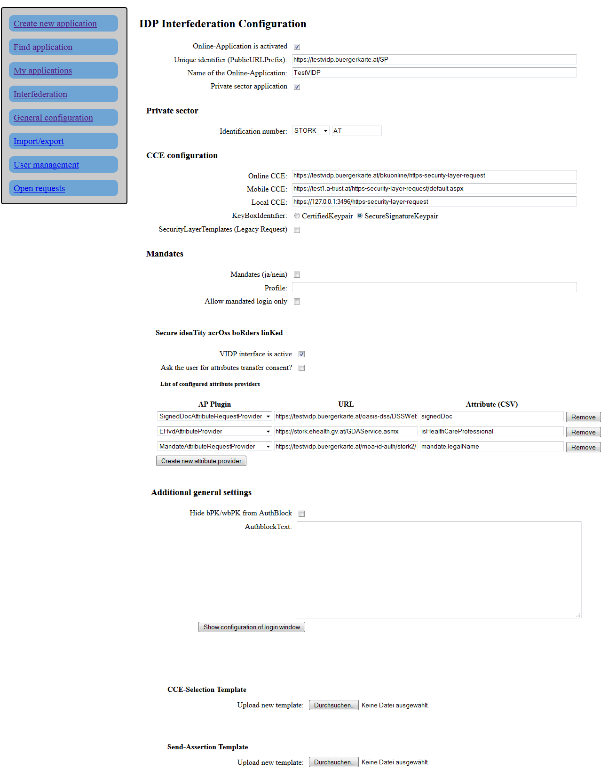

Figure 11: Example configuration of service provider application

Other functionality of MOA-ID web configuration interface
The option User management is used to set up new users of MOA-ID web configuration interface. These users will be able to login to the configuration interface and administer applications and settings. Figure 12 shows the interface used to create new users.

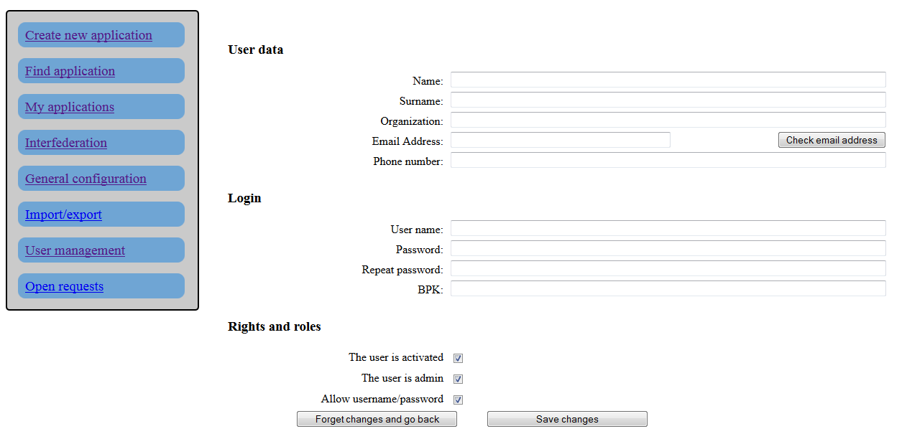
Figure 12: Creating new users

Configuring BKUOnline
BKUOnline is separate application serving as an online Citizen Card Environment. It is used in the authentication process as a component loaded in the user’s browser as a Java applet. Based on the request initiated by service provider’s application it establishes communication with user’s citizen card (smart card environment) and performs all authentication and signature related tasks.

Adjusting configuration file
The file /var/lib/tomcat7/webapps/bkuonline/WEB-INF/conf/configuration.xml contains basic configuration elements necessary to be reviewed before the BKUonline is used in productive system.
Whitelist section of this file contains the list of allowed DataURLs, e.g. the hosts which are allowed to call this instance of BKUOnline.

<Whitelist>
https://www\.formularservice\.gv\.at/BKU/.*,
https?://127\.0\.0\.1/.*,
https?://localhost/.*,
https://testvidp.buergerkarte.at/.*
</Whitelist>

Figure 13: BKUOnline whitelist hosts

Figure 13 shows the example configuration of whitelist section. The entries can be based on regular expressions.
Option SSL/disableAllChecks is used to deactivate all SSL certificate checks of calling instance. In production systems should be set to false.

Configuring SSL certificates
The relevant directories here are certStore/toBeAdded and trustStore, located under /etc/tomcat7/webapps/bkuonline/WEB-INF/classes/at/gv/egiz/bku/certs.
Directory trustStore contains the trusted certificates of Certification Authorities. The certificates of additional CAs should be copied to this location.
In directory certStore/toBeAdded copied are all the certificates used in the process of certificate chain building and verification, including the SSL certificate of BKUOnline and MOA-ID host system. Therefore, if the server SSL certificate does not contain complete chain, the certificates from that chain should be copied to this directory separately. After the restart, the application will check this directory, read and move its contents.
Should some certificates be left in toBeAdded after the application’s or server restart, the server administrator should check the logs for the errors. One of the reasons might be incorrect certificate format. In this case, the file should be converted and again copied to toBeAdded directory.

Logging configuration
The file /etc/tomcat7/webapps/bkuonline/WEB-INF/classes/log4j.properties contains logging configuration for BKUOnline module. Relevant for the configuration are the sections STDOUT appender and FILE appender, as well as log4j.rootLogger setting. The logging can be customized by enabling higher logging level (e.g. DEBUG instead of INFO) and by adjusting file paths to fit the local path and configuration needs.

Deployment of V-IDP package

In this section the system requirements and contents of deployment archive are described. They are followed with the list of necessary steps in the deployment process. When necessary, the list contains also additional brief explanations.
For the reference to specific configuration please follow the descriptions from Section 3: Configuration of V-IDP and its components.

System requirements
Please ensure that you have Tomcat 6 or 7 installed on the system, as well as updated Java SE 1.6 or newer. The Apache Tomcat 7.0.50 and Java SE Update SE 7 (current update) are recommended. The location of Java SE will be further referred as $JAVA_HOME.
This manual assumes that all included .war files are to be deployed on the same Tomcat instance. Should specific deployment scenario require separate Tomcat instances, the steps described in this manual should be reproduced on each instance, where applicable.

Package contents
The deployment package of MOA-ID contains the following directories, as described in Table 22: Contents of deployment archive.

Path | Description
conf | Configuration directories of MOA-ID and its components
doc | Documentation, including this manual
endorsed | Additional libraries
ext | Additional external libraries
source | Source code of Demo Online Application
tomcat | Apache Tomcat startup scripts
Table 25: Contents of deployment archive

The layout of conf directory is as describe in Table 23: Contents of configuration directory in deployment archive.
Path | Description
moa-id | Configuration of MOA-ID
moa-id-configuration | Configuration of MOA-ID web interface
moa-spss | Configuration of MOA-SPSS module
Table 26: Contents of configuration directory in deployment archive

Create MySQL databases
MySQL is preferred way to store data on V-IDP. Other RDMBS might be used as a backend storage, however, only MySQL is tested and supported for such purpose.
In order to deploy MOA-ID it is necessary to configure MySQL database user and to create the databases, as shown in Table 7: Preconfigured MySQL databases.

mysql -u root

create database `moa-id-config`;
create database `moa-id-session`;
create database `moa-id-statistics`;

use mysql;

create user 'newuser'@'localhost' identified by 'password';
grant all privileges on `moa-id-config`.* TO 'newuser'@'localhost';
grant all privileges on `moa-id-session`.* TO 'newuser'@'localhost';
grant all privileges on `moa-id-statistics`.* TO 'newuser'@'localhost';

flush privileges;
quit

sudo /etc/init.d/mysql stop
sudo /etc/init.d/mysql start

Figure 14: Setting up MySQL

Figure 14: Setting up MySQL illustrates how to create necessary databases and assign the database user with appropriate rights to use that databases. The username, password and database names are used further in MOA-ID configuration, as shown in the following subsections.
It should be noted that it is not necessary to carry further actions in the terms of database schema initialization. Such data will be automatically populated during MOA-ID deployment and initialization.

Copy and set up MOA-ID configuration files
The contents of conf directory, described in Table 25: Contents of deployment archive and Table 26: Contents of configuration directory in deployment archive should be copied to appropriate location, e.g. Tomcat configuration directory. Furthermore the contained files should be adjusted to reflect local configuration.
The example configuration is described in Section 2.4: MOA-ID configuration files, Section 3.2: Preparing basic MOA configuration as well as in Section 3.3: Preparing MOA configuration interface. The Tomcat directory layout under Debian is described in Section 2.2 Apache Tomcat instance.

Create and populate MOA-ID Keystore
The Java keystore (JKS) should be created and populated with trusted certificates of other interacting peers (PEPS, SP etc). It should contain the private key used to sign outgoing messages. The interacting peers should also install certificate used to sign the messages.
The example configurations of this step are given in Section 2.4: MOA-ID configuration files and Section 3.4: Configuring specific Stork support for MOA.
The list at STORK 2 website of other PEPS/VIDP interacting parties and updated certificate information can be consulted for further details.
Additionally, KeyStore Explorer can be used for manipulation over Java Key Store files.

Configure environment variables
As demonstrated in Section 2.3: Setting up and running Apache Tomcat instance, the configuration of Tomcat instance should be set up to contain reflect local configuration generated in previous steps.

Copy endorsed files to Tomcat’s endorsed directory
The files contained in directory endorsed should be copied to the Tomcat’s endorsed directory. These are libraries used by MOA-ID and its components.

Install JCE Policy files
In order to be able to support cryptographic configuration and options of IAIK libraries, it is also necessary to install Java Cryptography Extension (JCE) Unlimited Strength Jurisdiction Policy Files from the Java web site.
These files should be installed under $JAVA_HOME/lib/security, or in the location specified in README.TXT file distributed with the JCE archive.

Copy ext files to ext directory of Java distribution
The files from ext directory should be copied to $JAVA_HOME/jre/lib/ext directory of Java distribution. These are the IAIK libraries used for cryptographic functions.

Deploy included WAR files
The following three war files contained in the archive should be deployed:
- bkuonline.war
- moa-id-auth.war
- moa-id-configuration.war

The deployment can be done by copying the files to Apache Tomcat’s webapps folder. The structure of Tomcat installation under Debian is described in Table 2: Relevant Apache Tomcat paths.
Please adjust the naming schema of these files to reflect your local preferences. As reference you might use Table 3: Paths and URLs of deployed applications.

Configure BKUOnline and disable support for Austrian Test Cards
Based on the example given in Section 3.8: Configuring BKUOnline you can configure BKUOnline. Production systems must have SSL check enabled.

Install production SSL certificate
The production SSL certificate should be installed and enabled in Apache httpd and Apache Tomcat daemons.

Setup general settings of MOA-ID
As demonstrated in Section 3.2: Preparing basic MOA configuration, it is necessary to setup basic configuration of MOA-ID.

Initialize and setup MOA-ID web configuration interface
As demonstrated in Section 3.3: Preparing MOA configuration interface, it is necessary to configure and enable web access for MOA-ID configuration interface.

Setup MOA-ID and service provider application via web interface
Before the configuration of MOA-ID applications and general settings is approached, it is necessary to establish local MOA-ID configuration interface user. This is done by deactivating login option in configuration file moa-id-configtool.properties under moa-id-configuration directory. For such purpose the option general.login.deaktivate should be set to true. After the application is restarted the users are able to access the configuration application without providing user credentials.
Figure 12: Creating new users from Section 3.7 shows the interface used to create new web user. In default configuration and for the standard usage, all the fields under User data should be filled in, all checkboxes under subsection Rights and roles enabled and in the Login section BPK field might be left blank.
After the users are created, general.login.deaktivate should be set again to false and the application restarted.
As demonstrated in Section 3.5: General MOA configuration and Section 3.6: Setting up particular service provider, it is furthermore necessary to get through general MOA-ID setup, create web interface users and create service provider application.

Security
Last, but not least, you should check you internal organizational security guidelines and requirements, the recommendations of operating system and software platform used and harden your system.

Testing credentials for mobile citizen card environment
In order to be able to test authentication by using the mobile phone authentication credentials, the configuration specific to the application need to be adjusted.
This is done by selecting Interfederation on the left menu, then clicking to the particular application, and changing the content of its Mobile CCE field to https://test1.a-trust.at/https-security-layer-request/default.aspx, as shown in the following figure:

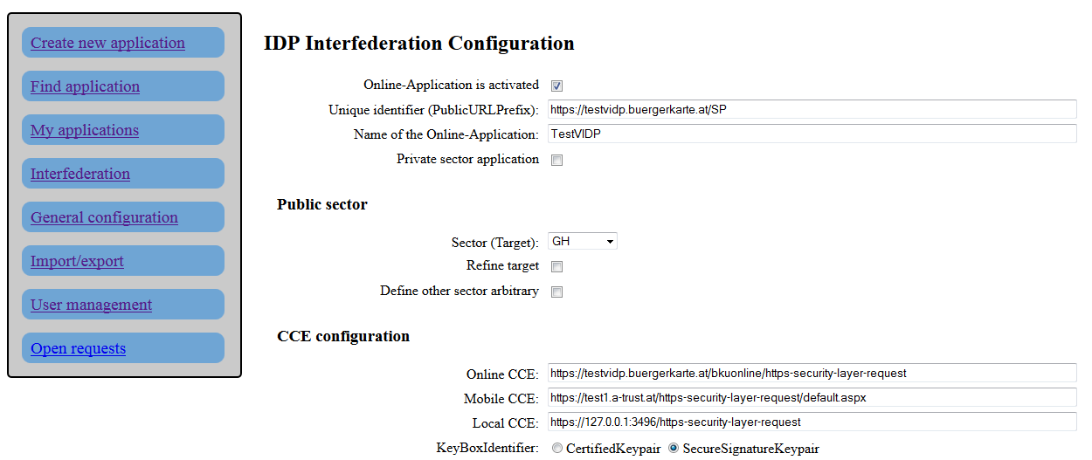
Figure 15: Application settings
This way the users will be able to use the following credentials:
Phone number: 103011122334455
Password: 123456789
TAN: 123456
Please note that this will disable usage of real mobile phone credentials. If you want to accept the real credentials under Austrian HandySignatur, the field Mobile CCE should be set to https://www.handy-signatur.at/mobile/https-security-layer-request/default.aspx.

References
- http://en.wikipedia.org/wiki/Executive_summary
- References are marked using a numbered list style referred to as References. This style has the following specifications: Calibri, 11pt., single line spacing, 6 pt. space from the previous paragraph.
- References within the text are in the form:
- [Az07] for a source with one author: A (capital) stands for the first letter of the author’s family name, z for the second letter of the family name, 07 stands for the year 2007 of publication,
- [Az07a], [Az07b], if a number of works by the same author exist from the same year,
- [XY00] or [XYZ01] for a source with two or three authors: X, Y and Z stand for the first letters (in capitals) of the authors in the sequence in which they are listed in the source.
- in the case of more than three authors, only the first author mentioned in the source is listed, by analogy with (1), e.g. [Az07].

In this document referred also as an online application
https://www.eid-stork2.eu/wiki/index.php/AT
https://www.eid-stork2.eu/wiki/index.php/WP4_-_MS_technical_information
http://keystore-explorer.sourceforge.net/
http://www.oracle.com/technetwork/java/javase/downloads

